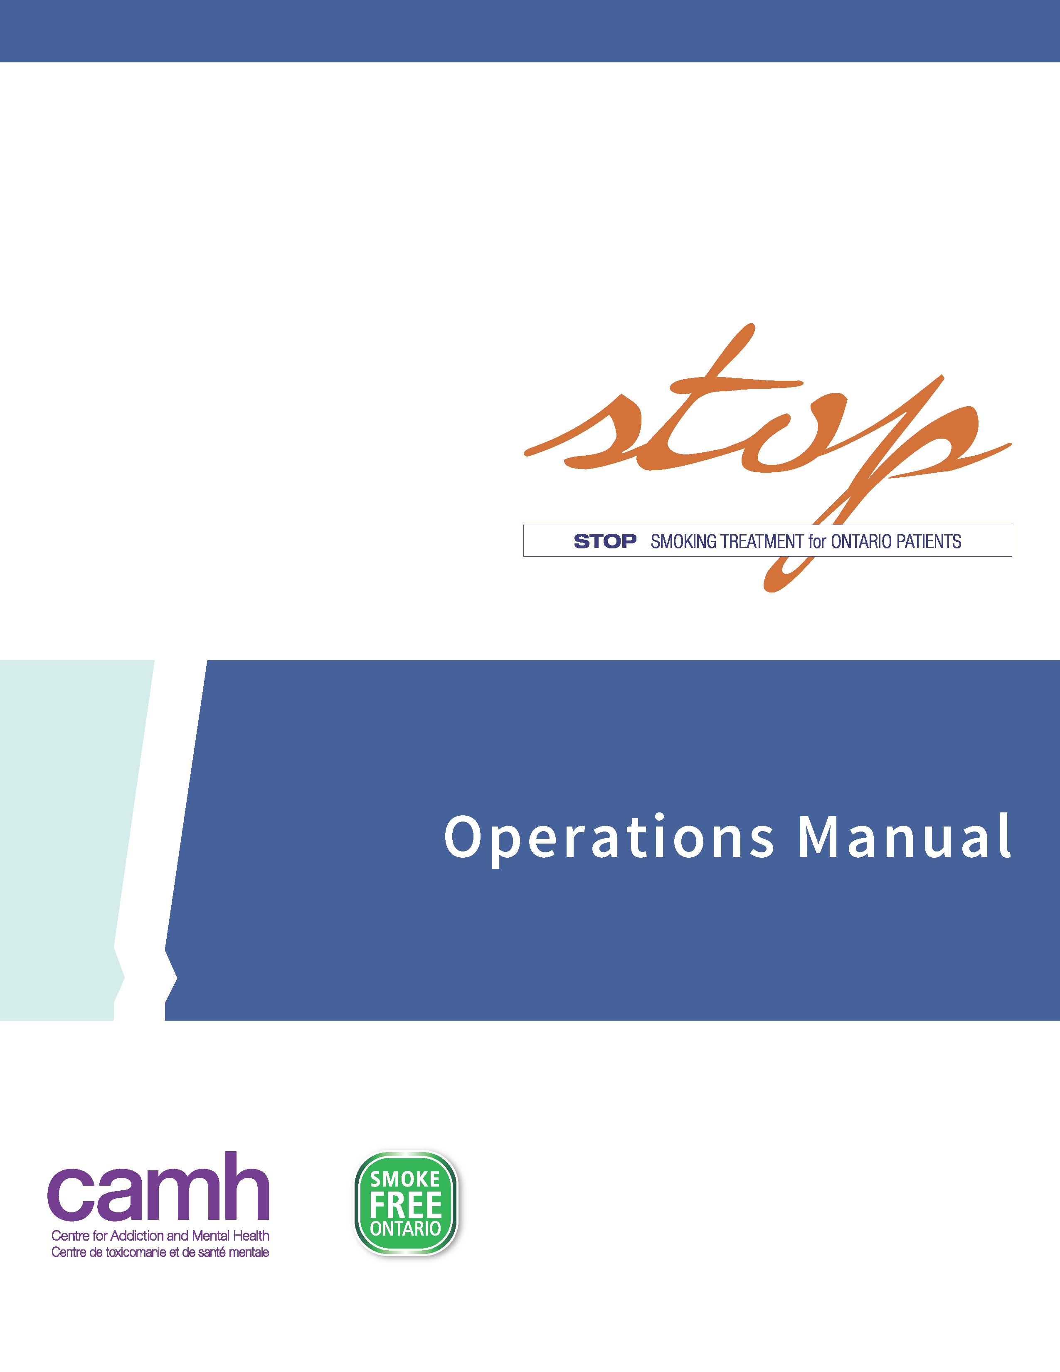

# Table of Contents

Introduction 3

Definitions and Abbreviations 4

Program Requirements 5

Program Implementation 6

Overview of Implementation Models 6

STOP Portal 6

Logistical Resources & Patient Engagement 7

STOP Program Promotion 7

Roles and Responsibilities 7

STOP Program Eligibility Criteria 9

STOP Program Enrollment 10

Practitioner-assisted enrollment 10

Patient Self-Enrollment 13

STOP Program Visit Form 14

Discontinuation from the STOP Program or Withdrawing Consent 15

Re-Enrolling Patients into the STOP Program 15

Provision of NRT and Medication Management 18

NRT Inventory and Ordering 21

Paper Documentation 26

Data Privacy and Information Management 29

Practitioner Resources 31

Supplements: 32

Supplement 1: STOP Mail-Out Model 33

Supplement 2: Paper Baseline Entry Tips 36

Supplement 3: Behavioural Counselling Guideline Algorithm: STOP Program (Brief Intervention Form) 37

Supplement 4: Algorithm for Tailoring Pharmacotherapy for Smoking Cessation 40

Supplement 5: Guide to Using Nicotine Replacement Therapy (NRT) Products: STOP Program 41

# Introduction

Thank you for choosing to partner with the **STOP (Smoking Treatment for Ontario Patients) Program**! Your partnership has helped make STOP the largest nicotine cessation initiative in Ontario helping over 300,000 people make a quit attempt through the Program.

The STOP Program provides evidence-based treatment interventions including cost-free Nicotine Replacement Therapy (NRT) to Ontarians who smoke commercial cigarettes and/or use other tobacco/nicotine products (e.g., e-cigarettes, cigars, chewing tobacco, water pipe, etc.). STOP operates within the Centre for Addiction and Mental Health (CAMH) and is funded by the Government of Ontario.

STOP partners with organizations across Ontario to deliver tobacco/nicotine cessation treatment to patients at Family Health Teams (FHTs), Community Health Centres (CHCs), Nurse Practitioner-Led Clinics (NPLCs), and Addictions and Mental Health Agencies (AMHAs), plus other sectors and organizations. Our overarching goal is to increase access to effective tobacco/nicotine cessation treatment and build practitioner capacity to provide this treatment. Participating organizations receive Nicotine Replacement Therapy (NRT) at no cost for their patients, as well as ongoing, comprehensive training opportunities in tobacco/nicotine cessation counselling for practitioners as part of our STOP Community of Practice.

This Operations Manual is a resource intended to communicate details related to the delivery and implementation of the STOP Program within your organization. We use the term ‘patient’ in this Operations Manual to refer to both patients and clients at your organization, who are participating in the STOP Program.

# Definitions and Abbreviations

* **CAMH**: Centre for Addiction and Mental Health
* **STOP**: Smoking Treatment for Ontario Patients
* **TEACH**: Training Enhancement in Applied Cessation Counselling and Health
* **NRT**: Nicotine Replacement Therapy (e.g., patch, gum, inhaler, lozenge, or spray)
* **AMHA**: Addictions and Mental Health Agency
* **CHC**: Community Health Centre
* **FHT**: Family Health Team
* **NPLC**: Nurse Practitioner-Led Clinic
* **Partnering Organizations**: Organizations (e.g., FHTs, CHCs, NPLCs, AMHAs) collaborating with the STOP Program to provide tobacco/nicotine cessation treatment (NRT and counselling support) to their patients.Within each organization, there may be multiple locations (sites) participating. We will also use the term “site” in this manual to refer to these organizations.
* **STOP Patients**: Patients of your organization who wish to quit or reduce their nicotine/tobacco use and are either referred or self-refer to enroll in the STOP Program.
* **STOP Practitioners**: Health practitioners at your organization who have received formal training in smoking cessation and are trained in implementing the STOP Program protocol at their site(s). *Practitioners who will be providing NRT have an obligation to perform all duties in compliance with the rules and regulations of their organization and professional bodies.*
* **Program Collaborator**: The designated main point of contact between your organization and the STOP team; may also be a STOP practitioner.
* **Executive Directors**: Responsible for signing the Program Agreement for their organization. They must ensure that all operations are consistent with the practices of their organization and that all contractual agreements are fulfilled.
* **STOP Program Staff**:People who work directly for the STOP Program. They are based at CAMH in Toronto and can include the Program investigators, Program manager, coordinators, research analysts/assistants, and administrative staff.
* [**STOP Portal**](https://ndsc3.inovex.ca/)**:** Web-based platform used by all STOP practitioners and collaborators for day-to-day implementation of the STOP Program.

# Program Requirements

**Here are the first steps to implementing the STOP Program:**

1. Submit a signed Program Agreement with CAMH. CAMH will share a pdf version of the Agreement with the site, which must be reviewed/signed by the Executive Director (or equivalent signing authority) at the partnering organization.
2. Have at least one practitioner at the partnering organization complete the STOP training requirements for implementation (see below).
3. Secure locked space on your premises to store the Nicotine Replacement Therapy products (should be stored separately from pharmaceutical samples to avoid accidental use).

**There are required trainings for all practitioners implementing the STOP Program:**

* Formal Smoking Cessation Counselling Training (such as TEACH, RNAO, OMSC or equivalent). For those who do not have such training, the TEACH (Training Enhancement in Applied Cessation Counselling and Health) Project at CAMH offers a Certificate Program (see [www.teachproject.ca](http://www.teachproject.ca)) which includes an Interprofessional Comprehensive Course on Treating Tobacco Use Disorder. Alternatively, STOP offers a condensed online training option, Fundamentals of Tobacco Interventions (FTI). Please reach out to your STOP coordinator to register for the FTI training.
* Program Operations Training: This training is offered regularly via webinar by the STOP coordinator team and will detail how to implement the Program within your organization, manage the NRT provided by STOP and communicate with the STOP team. Please email a STOP coordinator for specific dates and times.

# Program Implementation

## Overview of Implementation Models

There are two ways to implement the STOP Program:

1. **On-Site NRT Model**: participating sites will store NRT at their location and dispense to patients in accordance with the STOP treatment protocol; OR
2. **Mail-Out NRT Model**: CAMH sends a pre-packaged NRT kit directly to eligible patients.

The appropriate implementation option is determined based on the organization’s capacity and patient population. These options will be discussed between the Program collaborator and the STOP coordinator during the Initial Discussion.

Please note: organizations that are unable to store NRT at their site can only implement the Mail-Out Model (refer to **Supplement 1**).

*To maintain the collaborative nature of this Program, all organizations have the option to discuss additional or alternative implementation options with their STOP coordinator during the Initial Discussion meeting*

It is up to the STOP practitioner to determine the appropriateness and type(s) of NRT used, on a patient-by-patient basis. STOP practitioners may choose to provide one-on-one tobacco/nicotine cessation counselling with patients or provide counselling in a group setting. However, the NRT treatment must be provided on an individual basis. The Program allows the provision of **up to four “weeks” of NRT at each visit (note: one box of NRT typically provides one week of treatment), to a maximum of 26 weeks of NRT per patient within 12-months of enrollment.** If it is within one’s scope of practice, this may include off-label NRT treatment (if approved by your organization). STOP practitioners can adjust the NRT dose and type at each visit, as necessary. Additional details regarding provision of NRT can be found on **page 18.**

## STOP Portal

The STOP Portal is a web-based platform used by all STOP practitioners and collaborators for:

* Enrolling patients into the STOP Program;
* Monitoring patients’ tobacco/nicotine use and treatment progress;
* Providing and managing NRT; and
* Conducting assessments/follow-up surveys.

For more information about the technical aspects of the STOP Portal and how to navigate it, please refer to the ***STOP Program Online Portal Training Manual.***

## Logistical Resources & Patient Engagement

Upon completion of onboarding requirements (signed and approved Program Agreement, completion of all of the required trainings), STOP staff will enable STOP practitioner and Program collaborator access to the STOP Portal. Upon first accessing the STOP Portal, all STOP practitioners/collaborators must read and agree to the Terms of Use. Following this step, STOP staff will create a new site in the STOP Portal for the partnering organization and place the initial order of NRT.

Once your organization receives all supplies including NRT, STOP practitioners can begin enrolling patients into the Program. Patients can enter the Program in two main ways: practitioner-referral or self-referral. The STOP coordinators are available to discuss and support organizations in developing strategies to encourage their patients to enroll in the Program. For example, STOP can provide organizations with waiting room posters and cards for this purpose.

## STOP Program Promotion

The Program collaborator will seek the prior written approval of CAMH in respect of any communication activity or material developed for public distribution referencing or promoting the Program. CAMH staff will determine if Public Affairs’ prior approval will be required. All approved materials must include the following funding statement: *The Smoking Treatment for Ontario Patients (STOP) Program is funded by the Ontario Ministry of Health*.

## Roles and Responsibilities

### STOP practitioners are responsible for:

* Receiving training in smoking cessation counselling: Fundamentals of Tobacco Interventions (FTI) online course, TEACH Core Course certificate Program or other equivalent/accredited Program(s) (mandatory);
* Completing the STOP Operations Training webinar;
* Informing patients (e.g., via referral or waiting room posters) of the availability of the STOP Program at your organization;
* Ensuring that all required Program documentation is completed correctly, accurately and entered into the STOP Portal;
* Providing NRT to patients (if applicable) via your site’s inventory of NRT available through STOP;
* Tracking movement of NRT inventory using the STOP Portal Inventory Log, if applicable (Please note: only STOP practitioners with Program collaborator accounts will have this feature); and
* Conducting follow-up visits with patients to provide additional counselling and administration of NRT, as applicable.

### Program collaborators are additionally responsible for:

* Participating in the Initial Discussion with STOP staff to discuss Program implementation, in order to offer a feasible Program for their organization;
* Acting as the point-of-contact between their site and STOP staff;
* Communicating relevant STOP Program information to all STOP practitioners at their organization;
* Placing and receiving NRT orders and maintaining an accurate NRT inventory;
* Preparing and organizing shipments of forms to be sent back to STOP, if applicable;
* Ensuring that all STOP practitioners adhere to STOP Program guidelines and proper medication management of the NRT products; and
* Notifying STOP staff of any concerns or issues related to the Program.

### STOP Staff at CAMH are responsible for:

* Conducting the Initial Discussion, Operations Training and bi-weekly Knowledge-Exchange Practitioner Teleconferences;
* Working with collaborators to create a feasible Program for their site;
* Providing any necessary Program documents;
* Setting up STOP practitioners and Program collaborators with access to the STOP Program Online Portal;
* Filling NRT orders for each implementing site;
* Arranging for courier shipments when needed;
* Contacting STOP patients for follow-up surveys (at 3, 6 and 12 months);
* Providing support to each organization, as needed;
* Troubleshooting operational issues as they arise;
* Performing all evaluations on Program data;
* Ensuring there is a completed STOP consent form documented for each patient in the Portal;
* Responding to patient requests to withdraw from the Program and ensuring no additional data is collected from the patient;
* Responding to patient requests for access to and correction of their information in STOP; and
* Responding to patient inquiries and complaints about how STOP or CAMH manages or protects their information.

Questions from STOP practitioners and collaborators can be directed to [stop.study@camh.ca](mailto:stop.study@camh.ca).

## STOP Program Eligibility Criteria

### Inclusion Criteria:

Patients interested in enrolling in the STOP Program need to meet some basic criteria. These apply to both the Onsite NRT Model and the Mail-Out Model. Specifically, the STOP Program is available to patients who:

* **Are currently using tobacco/nicotine product(s) (not including NRT) or maintaining a recent quit attempt (within the last 30 days), for which the STOP practitioner deems NRT an appropriate treatment option.**
* **Are registered at your organization**: Please follow your organization’s standard practice regarding this criterion.
* **Live in Ontario**: Since the Program is provincially funded by the Ontario Ministry of Health, patients must live in Ontario.

Please Note: The product license on-label requirements must be followed when using the Mail-Out Model, given that this model involves NRT being sent directly from CAMH to the patient in a pre-packaged kit and not through the patient’s STOP practitioner. This means individuals must be smoking cigarettes in order to be eligible for the Mail-Out Model, in addition to meeting other criteria.

If you are implementing the Mail-Out Model, you must complete the Mail-Out Screener with your patient (see sample in **Supplement 1**) prior to enrollment to ensure the patient is eligible to receive the pre-packaged NRT kit. Please connect with your STOP coordinator for the fillable Mail-Out Form.

The above criteria are specifically for enrolling in STOP; your organization may have additional policies or directives that implementers will need to be familiar with and adhere to.

All data collection forms and medication management guidelines and procedures are described in the sections below. Additional NRT can be ordered at any time using the appropriate ordering systems.

# STOP Program Enrollment

STOP patients can enroll in the Program (complete consent, registration, and baseline questionnaire) in the following ways:

* + - 1. **Practitioner-assisted**: With their STOP practitioners during their initial appointment (“practitioner-assisted enrollment”); or
      2. **Self-enroll**: Directly online via My STOP Portal (patient-facing platform), in advance of their appointment with the STOP practitioner (“patient self-enrollment”).

## Practitioner-assisted enrollment

When the patient is enrolling into the Program directly with their STOP practitioner, the STOP practitioner must first obtain and document the patient’s verbal consent in the STOP Portal:

1. **Review the STOP Program consent form with the patient.** STOP practitioners can do this by:
   * Having the online consent form in the STOP Portal open on the computer screen, turning it to your patient, and having them read it.
     + If vision/literacy barriers exists, or the appointment is being conducted over the phone, please read the consent form aloud to them.
   * Providing the patient with a copy of the Consent form (paper or via email) that they can read. Note, they do not sign this paper form. Verbal consent will be recorded by the practitioner directly in the STOP Portal by completing the online consent form in the STOP Portal.

STOP practitioners must also ensure that the patient has the opportunity to ask any questions about the consent form, including Program purpose, procedures, risks and benefits of participating, and ability to withdraw at any time without penalty.

1. **Once the patient understands all of the consent information and provides their verbal consent,** **STOP practitioners will** **document this in the STOP Portal.** The steps for documenting verbal consent are as follows:
   1. Open a new online enrollment form and enter the patient’s Patient/Client ID and the date of consent.
   * Each patient enrolled in the STOP Program must be assigned a unique identifier (Patient/Client ID). This Patient ID # is assigned by the partnering organization; it must be unique for each patient and independent from their OHIP number or any other Personal Health Information (PHI).
   * The STOP Portal provides the ability to automatically generate a Patient ID with the click of a button.
   1. Select ‘I agree’ for the STOP Program Consent question and fill in the patient’s First Name and Last Name.
   2. If the patient consented to the following optional statements, please record this as well (select ‘I consent’ or ‘I do not consent’ to each statement). Please note: if they decline, this will not affect their access to STOP Program treatment. These are the optional statements:
   * *Optional Consent: You have the option of consenting to allow CAMH to collect your OHIP number to link your STOP information (as set out above) to your publicly-funded health care information at ICES for STOP Program planning and evaluation. You can refuse to provide your OHIP number without any impact on your eligibility to participate in the STOP Program.*
     + This question is regarding a concurrent external study investigating OHIP medical records over a 5-10 year period.
     + The patient’s identity will remain anonymous and confidential in the external study and only aggregate data will be used.
     + Please note: if the patient does not provide their OHIP number, the CAMH team will link the patient’s STOP information with ICES using other variables.
   * *Optional Consent: You have the option of consenting to allow CAMH to contact you about future research studies, programs, or resources on smoking and other factors that may be relevant to you based on your STOP information. You can refuse to consent to being contacted without any impact on your eligibility to participate in the STOP Program. If you consent to be contacted, CAMH will use the CONTACT INFORMATION you have provided below (or any updated or subsequent contact information you provide) to contact you.*
   1. For the question *“PRACTITIONER, please select one of the following:”* select the following radio button option to indicate that you (the STOP practitioner) obtained the patient’s verbal consent: *□ I have obtained the patient/client’s consent verbally (enter your name below).*
   * Please note: the verbal consent option must **always** be selected whenever you are collecting patients’ verbal consent.
   * STOP practitioners will then be asked to document their name so that there is a record of who obtained the patient’s verbal consent.
   1. Collect patient’s contact information (phone number and/or email).
   * STOP staff will contact all patients enrolled in the Program at **3, 6 and 12 months** following enrollment to conduct follow-up surveys by email or phone. If a patient does not have access to an email address or phone number, STOP practitioners may be asked to complete the Follow-Up Survey (when they are due) in person if they are still in contact with the patient.
   * Please ensure that the patient understands that the follow-up surveys are very important parts of the STOP Program. This is emphasized because the data collected at these follow-up surveys are provided to sites and funding agencies and are used for Program evaluation and quality improvement purposes.
2. **Once the STOP practitioner has documented the patient’s verbal consent, they can proceed to complete the next section of the STOP enrollment form with the patient on the STOP Portal, the Registration and Baseline questionnaires**:

## Registration Questionnaire

* + The Registration Questionnaire contains pertinent questions such as the patient’s Date of Birth, Gender, Height, Weight and the tobacco/nicotine product(s) that they are seeking help to quit. This form is to be completed by the STOP practitioner or the patient (with the STOP practitioner’s assistance, as needed), prior to receiving counselling and/or NRT. The answers provided in the Registration Questionnaire can help inform the treatment of the patient.
  + **IMPORTANT:** EVERY QUESTION REQUIRES AN ANSWER in order to enroll the patient in our system. Please note: skip logic is already built into the online survey.

## Baseline Questionnaire

* + The Baseline Questionnaire contains questions assessing Other Substances, General Health, Demographics and Background.
  + On the Baseline Questionnaire, please encourage patients to answer every question, as the information collected in this questionnaire is useful to guide the patient’s course of treatment and is important for STOP Program and Ministry Reporting purposes. However, if a patient does not wish to answer a given question on the questionnaire, please select the “Don’t know/Prefer not to answer” option (if available).

When you reach the end of the STOP Program enrollment, you can proceed with completing a Visit Form (see page 14) and initiating treatment.

## Patient Self-Enrollment (online, at home, or in clinic)

Once referred to the Program by their practitioner, patients also have the option of enrolling into the STOP Program online on their own, using the patient-facing version of the STOP Portal, “My STOP Portal”.

In order to use My STOP Portal, patients must first meet the standard eligibility criteria for the Program and have a valid email address. If they meet these requirements, STOP practitioners can provide them with the direct link to My STOP Portal (please reach out to your STOP coordinator for the link) before their first appointment.

Please note: The technical components of My STOP Portal (e.g., how to find a patient’s self-enrollment online) are covered in more detail in the ***STOP Program Online Portal Training Manual***. Below, is a brief overview.

STOP patients can access the My STOP Portal link using their tablet/smartphone/computer (or any device with internet access). On My STOP Portal, patients will be asked to create a My STOP Portal account using their email address and then proceed with completing the online enrollment form. This can be done at home or while in the clinic waiting room (e.g., on a tablet) before their first appointment with the STOP practitioner.

Once the patient has set up their My STOP Portal account and completed their STOP self-enrollment, they will receive an automated email notifying them to visit their STOP practitioner within 45 days. This is because the STOP practitioner must review and finalize the patient’s self-enrollment before any STOP Program treatment can be initiated. The 45-day period is set to ensure that their answers remain up-to-date and relevant when the STOP practitioner reviews them.

When the self-enrolled patient meets with their STOP practitioner for their first visit (within the 45-day period), the practitioner will need to search for their enrollment in the Portal (using the patient’s email address or Reference Number) and review all of the information submitted through self-enrollment. The consent section will have been filled out by the patient already, however you will need to complete the *“PRACTITIONER: please select one of the following:”* question by selecting *“The patient/client self-enrolled and provided consent directly”* option.

Since the patient will have already completed the baseline assessment, the STOP practitioner will simply need to review and address any missing information or make any updates, if needed.

**IMPORTANT NOTES:**

* Since the patient self-enrolled via My STOP Portal and provided their consent directly online, you do not need to obtain and document their verbal consent.
* If the self-enrolled patient does not make an appointment with the STOP practitioner within 45 days, their self-enrollment will be archived automatically and cannot be accessed by the STOP practitioner or patient. The patient will either need to self-enroll again or go through a practitioner-assisted enrollment.

## STOP Program Visit Form

A “Visit Form” must be completed by the STOP practitioner at every tobacco/nicotine cessation visit when NRT is being provided, including during the initial appointment after the enrollment is completed. It is divided into three sections:

1. **Tobacco/Nicotine Use:** The first section of the form includes a few questions for assessing the patient’s tobacco/nicotine use at each visit.

* As with the Registration Questionnaire, all questions require an answer. Skip logic (arrows) and question formats must be followed (e.g., numeric-only answers where appropriate – see **Supplement 2** for more information).
* Although STOP only requires responses to these specific questions in the visit form, practitioners are encouraged to conduct a more-thorough assessment and counselling session. After the assessment is complete, the STOP practitioner may determine which NRT treatment is most appropriate.

1. **Behavioural Counselling:** In the second section of the Visit Form, the practitioner will need to record the duration of the behavioural counselling provided at each visit.

* Please make sure that behavioural counselling is provided to the patient at each visit. Please see **Supplement 3** for a Behavioural Counselling Guideline Algorithm (“Brief Intervention Form”).

1. **NRT Provision:** In the third section of the Visit Form, the practitioner will record the number of weeks of NRT being provided at that visit, including lot #s and expiry dates. We request that a maximum of 4 weeks of NRT be provided at any given visit and that patients are seen every 2 to 4 weeks for behavioural counselling and NRT dose adjustment, as needed.

* Each patient is eligible to receive up to 26 weeks of NRT over the12-month period of enrollment.
  + **Practitioners should check the expiry dates of all STOP NRT products in their cabinet prior to providing NRT and ensure that the earliest-expiring NRT products are used first** (Please note: products expire at the ***end*** of the month indicated on the expiry date).
* Please see the Provision of NRT and Medication Management section (page 18) for further instructions on providing NRT.
  + Please note: if you wish to provide more than 4 weeks of NRT due to special circumstances, you require pre-approval from a STOP coordinator, which you will need to reference in the comment field. Also, note that there are no exceptions to the 26 weeks of NRT per patient per year limit.
* When you enter the NRT information into the Portal, the total weeks of NRT provided to date is automatically calculated and displayed within the patient’s profile. This should help in planning the remaining treatment.

At the end of each Visit Form, the practitioner must record their name. The Form also has a **Comments** section, which can be used to record any special considerations with respect to the patient’s treatment (note: if forms are completed on paper and sent to STOP for entry, these comments are **not** entered).

## Discontinuation from the STOP Program or Withdrawing Consent

Due to the long-term nature of this Program, patients are not considered ”withdrawn” or “dropped out” if they discontinue use of NRT, fail to attend follow-up appointments, or relapse to smoking. Their 26 weeks of NRT available through STOP does **not** have to be consecutive. For example, if a patient relapses and does not receive NRT for some period of time, they are **not** removed from the Program. They are allowed to return to the STOP Program at any time if they choose to, provided they have not used up their full 26 weeks of NRT and are within one (1) year from their enrollment date.

However, if a patient does wish to formally withdraw their consent to participate in the Program, theycan be withdrawn directly on their Patient Profile in the Portal. The process for withdrawal is outlined in the***STOP Program Online Portal Training Manual****.* Once a patient has officially withdrawn, we will not contact them for follow-up phone calls/emails and they will no longer be eligible to receive more STOP NRT for that enrollment. If a patient chooses to withdraw from the Program during a follow-up completed by CAMH staff, practitioners at your organization will be notified by an automated STOP Portal email.

STOP practitioners have the right to terminate clinical care for a STOP patient in certain circumstances, such as violent or harassing behaviour. STOP practitioners can withdraw the patient’s enrollment directly in the STOP Portal or can notify CAMH staff.

## Re-Enrolling Patients into the STOP Program

Consent to participate in the STOP Program is valid for one (1) year from the date of enrollment. Patients who are still involved in the STOP Program one year after enrollment will be required to enroll again (i.e., complete a new Consent Form, Registration Questionnaire, and Baseline Questionnaire). This section also applies to patients who have withdrawn their consent to participate, but wish to re-enroll in the Program.

Examples where a patient would need to re-enroll into the STOP Program:

* Patient has been enrolled for one full year (from the date of enrollment on the original Consent Form), **continues to use tobacco/nicotine (or quit for no more than 30 days)**, and wishes to continue with treatment.
* Patient has explicitly withdrawn consent within the one (1) year from the time of enrollment, but **is still using tobacco/nicotine** and wishes to enroll in the Program again. The exception would be if a patient had reached 26 weeks of NRT already before they withdrew.

**A patient can re-enroll into the STOP Program in two different ways:**

1. Directly with the STOP practitioner (practitioner-assisted enrollment); or
2. Through the My STOP Portal self-enrollment page (patient self-enrollment)

Please refer to the above section, STOP Program Enrollment (page 10) for additional details.

### Re-enrollment via STOP Practitioner

STOP practitioners can re-enroll a patient into the same clinic/site directly on the STOP Portal.

* The patient will first need to agree to consent to the Program again – follow the same steps as you would to enroll a new patient**.**
* Please add “**R1-**” to the beginning of the original Patient ID (e.g., **R1-**12345) to indicate that the patient has re-enrolled in the Program. If it is the second re-enrollment, you would add “**R2-**” to the ID#, and so on.
* Complete the Registration and Baseline questionnaires and Visit Form as you would for any newly enrolled patient. Please ensure you have the new Patient ID with the “**R1-**” prefix on any paper forms (if you use them).

*At a patient’s first visit after re-enrolling, you can ask whether they have any leftover NRT from their original enrollment. If the product has not expired, ask them to use up that NRT first before providing any more products (or at least take this amount into consideration when deciding how much to provide).*

It is **extremely important** that re-enrolled patients have the “**R1-**” prefix added to their Patient ID. Failing to include this could result in none of the patient’s re-enrollment data being saved in our database, as it will not accept duplicate ID#s (if it is the second re-enrollment, remember to add “**R2-**” to the ID# and so on).

If a patient is re-enrolling because they had withdrawn from the Program when contacted for follow-up, please explain to the patient that completing the follow-ups is a very important component of the STOP Program in order for us to evaluate its effectiveness.

Please note: the re-enrollment procedure is not intended to extend the 26-week limit. If the patient reaches the 26-week limit, please do not re-enroll them right away; they will have to wait until a full year has passed (since the day they initially enrolled) in order to re-enroll.

### Re-Enrollment via My STOP Portal

Patients can agree to consent and complete the Registration and Baseline questionnaires using the My STOP Portal self-enroll link that you have provided. This link can only be used if the patient’s previous enrollment has expired, i.e. a full year has passed since the previous enrollment.

* Please be sure to review all responses in the self-completed questionnaires when you complete their enrollment
* Please remember to add “**R1-**” to the beginning of the original Patient ID (e.g., **R1-**12345) to indicate that the patient has re-enrolled in the Program. If it is the second re-enrollment, you would add “**R2-**” to the ID#, and so on.

Please contact your STOP coordinator with any questions about the re-enrollment process.

# Provision of NRT and Medication Management

This section will introduce you to guidelines related to the provision of NRT for tobacco/nicotine product cessation as part of the STOP Program. STOP has developed guidelines for the provision of NRT (below), which are consistent with current evidence in smoking cessation treatment, as well as our goals for providing long-term tobacco/nicotine cessation support to our patients. Please refer to **Supplement 4** for the “STOP Program Sample NRT Algorithm”. In addition, please see **Supplement 5** for a “Guide to Using Nicotine Replacement Therapy Products” offered through STOP.

**Please note:** administering NRT for any tobacco/nicotine product other than cigarettes is currently considered off-label. While off-label dispensing for this indication is permitted by the STOP Program, it must be within your clinical scope of practice to do so. **Please follow your own organization’s rules and guidelines regarding off-label dispensing of NRT.**

The STOP Program may offer the following products*:

* Patch (21mg, 14mg and 7mg)
* Inhaler (10mg; 4mg delivered)
* Gum (2mg)
* Lozenge (2mg)
* Spray (1mg)

\**Inventory is subject to change*

We encourage STOP practitioners to use their clinical judgment in deciding the most appropriate type(s) and dose(s) of NRT to meet each patient’s needs and to develop a plan to taper down the dose over time, if needed. Off-label dispensing is permitted by the STOP Program (e.g., dispensing NRT for cessation treatment of tobacco/nicotine products other than cigarettes, dispensing of more than 21 mg of NRT per day). In some cases, such as a high NRT dosage, physician oversight may be required. **In all cases, please follow your own organization’s rules and guidelines regarding off-label dispensing of NRT**.

Please note: the products we supply, while at no cost to partnering organizations, are not samples and should not be provided as such.

## Guidelines for the Provision of NRT

The following rules and guidelines must be followed when providing NRT to patients:

1. **Provide a maximum of 4 weeks at a time:** This is to encourage patients to come back for regular visits to benefit from the counselling component of the STOP Program delivered by the implementing practitioner. In addition, the purpose of this rule is to minimize NRT waste. Exemptions may be granted only in special circumstances - please email STOP in advance with the reason for this request in order to obtain approval. This email communication with STOP needs to be referenced in the comments section of the visit form when providing NRT for more than 4 weeks.

Please note: Weeks are defined in terms of treatment period and not dosage of NRT, as treatment is tailored to the individual.

1. **Provide a maximum of 26 weeks of NRT within one year:** The 26 weeks of treatment does not have to be consecutive.

Please note: there are absolutely no exceptions to this rule and the 26-week amount cannot be extended.

1. **Provide only 1 type of short acting NRT at a time:** Short-acting NRT includes the nicotine gum, lozenge and inhaler; only one type should be provided at each visit to reduce the chance of waste and the patient receiving more than they will use.

Please note: short-acting products are designed for breakthrough cravings only and should not be used as the main source of nicotine replacement for most patients. If a patient is unsure as to which type of short acting NRT they prefer, STOP practitioners can give individual pieces of the STOP products to patients to try. Please follow the steps outlined in the “Inventory Log” section (page 21) to document NRT products used for this purpose.

### LOT #Finding the LOT Number

On each visit form, practitioners must record the LOT number of the products provided. The LOT number can be found on the side of a product box, next to the expiry date. The LOT number is recorded for safety reasons to track the NRT in case of a product recall. In addition to recording the LOT number, please check the expiry date prior to providing NRT to patients.

Please note: a STOP sticker covers the barcode to deter patients from trying to return it for a refund.

### Returned and Expired Medication

Patients may decide to return NRT products to a STOP practitioner due to an adverse reaction, a decision not to use NRT, or another factor. **If a product is returned, it cannot be provided to another patient, even if the box is unopened.** **Please** **clearly label the box as “Returned”**.

If you notice that an NRT product is going to expire before you can provide it to a patient, or if the expiry date has already passed, please remove this product from your inventory and perform an Inventory Adjustment in the Portal (see page 22 for instructions). Again, **please clearly identify the product as “Expired”** if necessary so that it is not accidentally given out.

**Returned and expired products should not be thrown in the garbage.** If you have the proper facilities to dispose of these products, you may do so. In this case, you must provide the product quantities, lot numbers and expiry dates to a STOP coordinator first. If you do not have safe disposal, you may send all returned and expired products to CAMH.

**If you are concerned about any products that are set to expire within the next three (3) months, please contact your STOP coordinator.**

# NRT Inventory and Ordering

STOP staff will place the order for your first NRT shipment, based on the number of expected patients in the first month of the Program (as determined at the Initial Discussion). Practitioners with Program collaborator accounts are responsible for placing subsequent NRT orders.

Please note the following regarding NRT ordering and delivery:

* NRT orders are placed through the online STOP Portal
* Please allow 1-2 weeks for delivery to your organization
* Once NRT is delivered to the partnering organization, staff will be required to store the NRT in a secure, locked space, separated from pharmaceutical samples, until it is provided to a patient. The newly delivered products should be placed behind the old stock to ensure you are providing the earliest-expiring products first. The order also needs to be “Received” on the online Portal.

STOP staff may modify your NRT order request according to your online NRT inventory levels and your average monthly usage. In certain circumstances, STOP staff may not be able to fulfill an order as requested (e.g., if stock of a particular product is limited). Unfortunately, we are unable to accommodate requests for specific brands or flavours of NRT products.

Consistent with good medication management practices, NRT is shipped from our distributor based on the expiry date. Accordingly, STOP practitioners are required to provide products with the **earliest expiry dates first.**

Please note: **products expire on the last day of the month listed on the expiry date**. As long as the product is used by the patient before that date, it does not count as “expired.” For example, if the expiry date says EXP 07 2025, the last date it can be used is July 31, 2025.

## Inventory Log

The purpose of the Inventory Log is to keep track of all NRT products and help manage your inventory so that you can place NRT orders in a timely fashion. The Inventory Log is intended to reflect the quantity of each product available to be dispensed at a given time.

Inventory Log and Orders are completed online using the STOP Portal, where a key feature is a real-time update of your online inventory in your Inventory Log each time you provide NRT to a patient. This eliminates the need to keep paper records of your NRT inventory. **If Visit Forms are not entered directly online at your site, there may be a discrepancy between the online Inventory Log and the actual amount of inventory at your site.**

In the “Inventory and Orders” page of the Portal, current inventory levels are displayed in a table (see below).

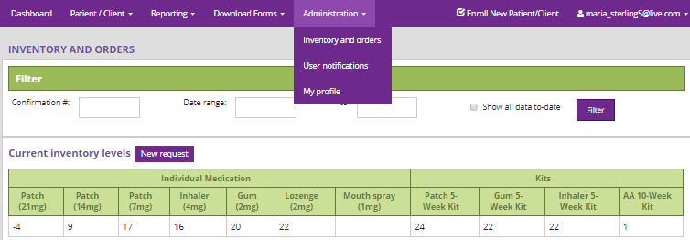

In order to maintain an accurate inventory on the Portal, there are several situations that must be documented. The online Portal is automatically adjusted once an order is received on the Portal and when NRT is provided via a Visit Form:

* Providing: The Portal automatically updates inventory when providing NRT to patients.
* Receiving: Always indicate that you have received your new NRT shipments on the Portal by selecting “Full Receipt” in the Action column (see NRT Ordering section below).

### Inventory Adjustments

In some cases, the online inventory needs to be manually adjusted through an **Inventory Adjustment**:

* Expiring NRT: Perform an Inventory Adjustment if NRT is soon to expire (or has already expired), and needs to be sent back to CAMH/destroyed on site at a local pharmacy or via medical disposal. NRT shipped to CAMH needs to be ***subtracted*** from your current inventory levels.
* Trial boxes: If opening a trial box (to provide ***one or a few*** test pieces to an ***enrolled STOP patient*** during a visit), perform an Inventory Adjustment, indicating “Trial box” as the reason for the adjustment and ***subtract*** one box of the NRT product that you will be opening for this purpose.
* Product transfer between sites: Although transfers of NRT products between sites of the same organization are not encouraged, it may happen in special circumstances. All sites involved have to do Inventory Adjustments, indicating “product transfer to/from [specify site name]” as the reason for the adjustment. The site ***receiving*** the NRT needs to ***add*** the items to their inventory. The site ***giving out*** the NRT needs to ***subtract*** the items from their inventory.

When completing an inventory adjustment, you must **enter the reason** for the adjustment in the comments section of the Inventory Adjustment pop-up box.

The Inventory Adjustment table works by addition and subtraction. For example, if a box of lozenges is opened for trial use, you will need to enter “-1” in the table for lozenges.

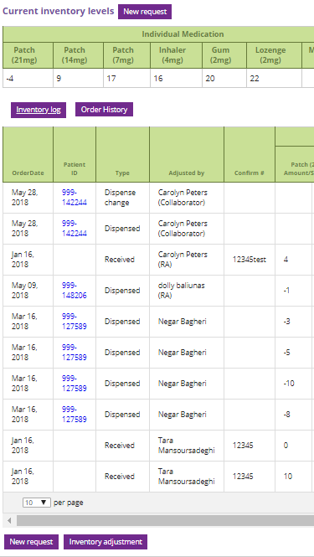 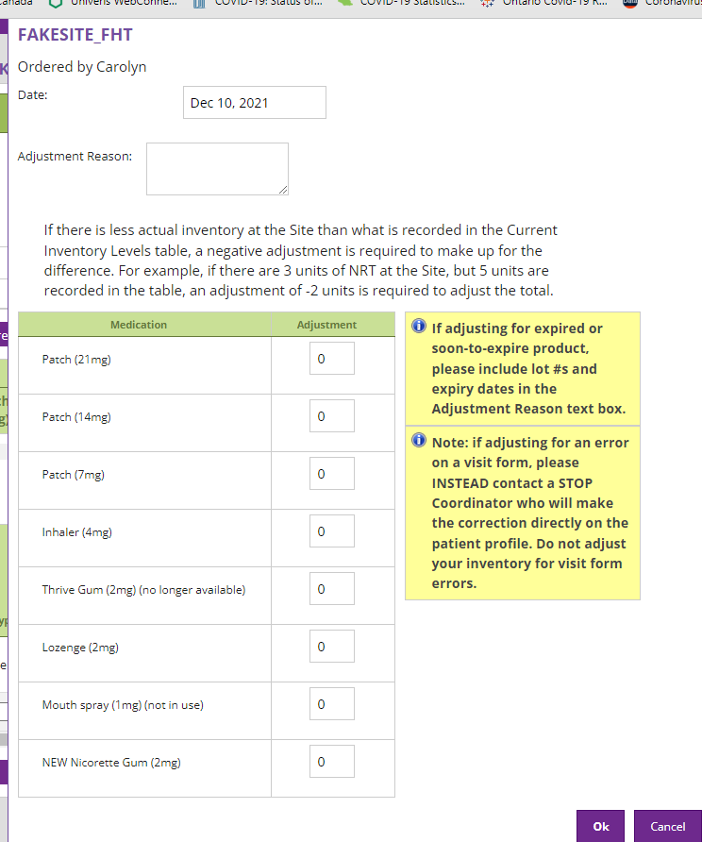

Please note: For some sites, if they operate under the “Collapsed Model” (one organization with multiple sites that are combined as one in the Portal), the online inventory needs to reflect the total NRT across **all** of the sites belonging to that organization. Additional individual site NRT logging might be required in order to keep your inventories accurate. For more information on the “Collapsed Model”, please contact one of the STOP coordinators.

Please contact a STOP coordinator if there are any questions at all about inventory management.

## NRT Ordering

New NRT requests (i.e., when your organization requires a new product shipment) are placed through the STOP Portal, under Administration → Inventory and Orders. The STOP Portal allows **Program collaborators** to order and receive new NRT inventory for their organization. Only those with a **Program** **collaborator** account can place an order for new NRT. The different account types are described in the ***STOP Program Online Portal Training Manual***.

The NRT request system is set up so that the Program collaborator at each site can place a “Request” online through the STOP Portal. At CAMH, our staff will review all of the requests and place the actual orders with our supplier. Ideally, **your new request plus your current inventory should last for about two months [i.e., Your New Request = (your Average Monthly Usage x 2) – (your Current Inventory)]**. Please keep to no more than two months’ onsite to minimize waste. The advantage to this system is that all inventory movements (NRT received and provided) are electronically tracked. Before placing a new NRT order “Request”, it is very important to ensure that your online inventory matches the actual count of NRT at your site. Make sure all previous orders are received, all outstanding Visit Forms (if any) are entered, all expired products are removed, and all product movements are documented through an Inventory Adjustment on the Portal.

The actual amount of NRT ordered by CAMH will appear in the “Order” column under each product type (see figure below). Once the NRT order has been received by you, the amount displayed will be the amount of NRT that CAMH actually *ordered* (which may not necessarily be the amount *requested* by the collaborator). As mentioned above, CAMH may modify orders based on availability of product or other factors. If you require additional products, you will need to place another request once the NRT from your previous request has arrived at your site and is received using the STOP Portal receiving options (“Full Receipt” if everything CAMH ordered has arrived at your site; “Partial Receipt” if products that CAMH ordered were different from what was received at your site).

On the online Portal, from the “Administration” drop-down menu at the top of any screen, select “Inventory and Orders”. Your Order History will be displayed. The pictures below illustrate the procedure of making and monitoring the status of NRT orders. Please see the***STOP Program Online Portal Training Manual***for details of NRT ordering procedures.

All orders are manually processed through a third party distributor. Please allow for up to 2 weeks for delivery to your site.

The figure below shows the steps for placing an order on the STOP Portal. Once the New Request button is clicked, a pop-up window appears that pre-populates the current inventory and an average of the past monthly usage of NRT for all patients at the site. After the order is requested (first column populated of order history table), CAMH staff review and place the order with the distributor (amount is populated in second column of order history table). Once the NRT arrives to the site, the Program collaborator must count it, then click on Full Receipt for the STOP Portal inventory to be updated.

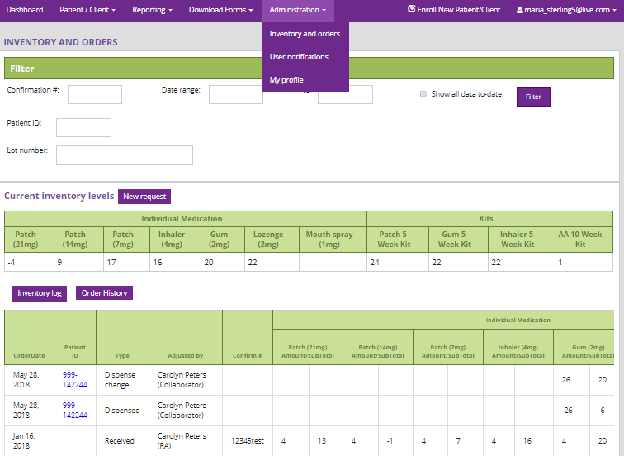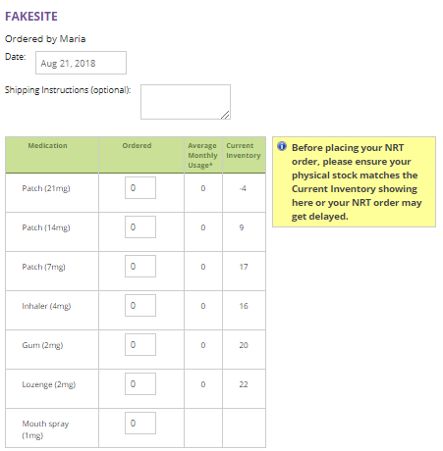

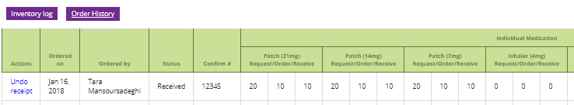

# Paper Documentation

All documentation is to occur in the STOP Portal; however, there may be some instances where paper-based enrollments are required. The following section describes additional instructions in the event that STOP practitioners need to complete any paper forms (e.g., due to internet outage, unable to access STOP Portal, etc.).

Please note: copies of all forms can be found on the STOP Portal by going to “Download Forms” in the STOP Portal menu bar.

**Reminder: Once the STOP Portal can be accessed, STOP practitioners are strongly encouraged to enter any completed paper forms into the STOP Portal at their earliest convenience** (with the exception of the Baseline Form if choosing Enrollment Option B: Accelerated enrollment. See the ***STOP Program Online Portal Training Manual***for details).Once these forms are entered into the Portal, they can be shredded. You should only send paper forms to CAMH if you are unable to enter the paper forms into the STOP Portal and require support from CAMH.

* **Consent:** The STOP Program consent form does not require a physical signature, as it is always documented directly online (either verbal consent collected from the patient via their practitioner, or directly submitted by the patient via My STOP Portal). We provide read-only versions (online or hardcopies) of the consent form only for accessibility purposes. If a STOP practitioner does not currently have access to the STOP Portal at the time of enrollment, they can follow their organization’s policies for temporarily documenting verbal consent (whether on paper or in the organization’s EMR) and PHI (name, contact information, etc.). Once they gain access to the STOP Portal, they can initiate a new patient enrollment and enter the patient’s information and document their verbal consent directly in the Portal.
* **Registration Questionnaire, Baseline Questionnaire, and Visit Forms:** These forms all have paper versions that can be completed in the event that you are not able to access the STOP Portal. All paper versions will have a “Site Use Only” footer box (see image below).

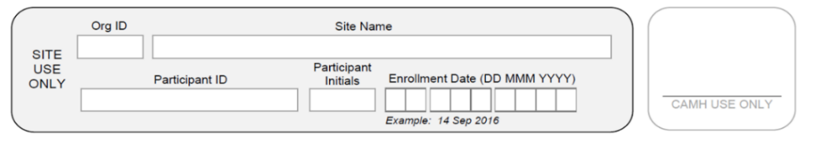

Please make sure to fill out **all** of the required information in the box (including the Org ID, Site Name, Patient ID, Patient Initials, and Enrollment Date) before completing the form, if sending it to CAMH. Otherwise, we may not be able to identify which patient the form belongs to. The “Org ID” is the 3-digit code that is assigned to each organization by STOP staff.

If a patient completes the baseline assessment on paper, they may intentionally or accidentally leave a question blank. When entering these baseline questionnaires into the STOP Portal, do not select a response for questions that were left blank. Please also see **Supplement 2** for instructions on how to enter paper baselines into the STOP Portal.

## Administrative Reminders

Documentation   
STOP practitioners are encouraged to enter all forms (Registration and Baseline questionnaires, Visit Form) directly into the STOP Portal. This will result in a complete patient profile and easier NRT inventory management. Furthermore, this will help to expedite the appointment because the portal will facilitate built-in survey skip logic enabling only relevant questions for your patient. There are also online validation checks and assisted guidance for clinical decision support. You will be able to download this information into a PDF document that can be uploaded to your organization’s electronic medical records system. If required, paper forms can be downloaded from the STOP Portal.

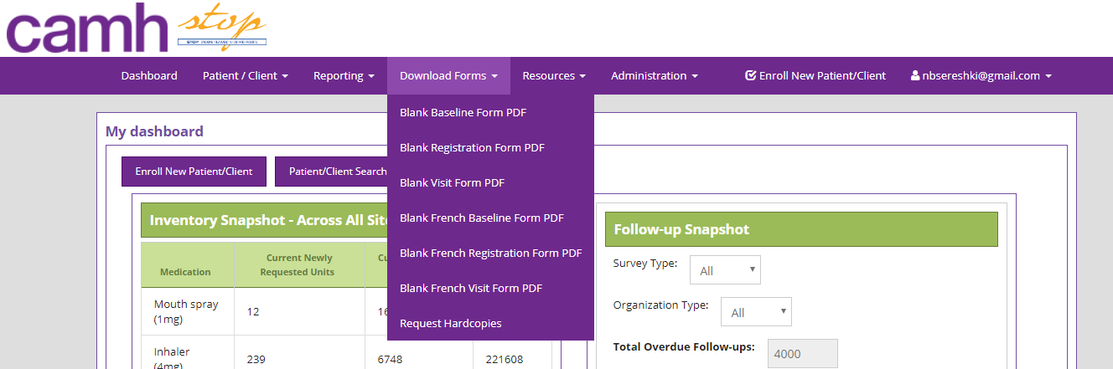

### Documentation Pick-Ups

Should any paper documents be required to be sent to STOP (i.e., if you are unable to enter the Registration, Baseline and Visit forms into the STOP Portal due to a technical issue and need CAMH to do it), please connect with CAMH STOP staff to arrange a courier to pick up the document(s) from your site.

Please note: All paper forms (Consent Form, Registration Questionnaire, Baseline Questionnaire, Visit Form) for patients enrolled prior to August 27, 2022 must be sent to the STOP Team; these forms are considered research study data, as they were completed prior to our transition from research study to the clinical Program STOP has become. Any paper visit forms for patients enrolled prior to August 27, 2022 (irrespective of the actual visit date) must also be sent to the STOP Team.

Registration and baseline questionnaires completed on or after August 27, 2022 **do NOT** need to be sent to the STOP Team as long as you have entered them directly into the STOP Portal. If you are unable to enter these forms into the STOP Portal, you can send them to STOP for entry. Once entered, we will shred the paper documentation. This only applies to enrollments on or after August 27, 2022.

STOP practitioners are free to scan or photocopy these forms for their own records prior to shipping the originals.

Please note: if un-entered forms are misplaced while in transit to STOP, STOP staff will ask the site if a new baseline can be completed if it is within the appropriate time range (i.e., within 30 days of enrollment).

# Data Privacy and Information Management

### Patient Requests for Access to or Correction of their Information in STOP

STOP and sites will first direct patients to access their STOP information through the My STOP Portal. Where a patient does not have a Portal account or the information is not available to them through the account, ask the patient to contact [***stop.support@camh.ca***](mailto:stop.support@camh.ca) or 416-535-8501 x34455 to obtain access to their records in STOP. The STOP coordinator will respond to access requests and consult with the CAMH Information and Privacy Office as per CAMH policies.

Patients can review their contact information on the STOP Portal using their My STOP Portal account. If they would like to request corrections to this or other information, these requests can be directed to [***stop.support@camh.ca***](mailto:stop.support@camh.ca) or 416-535-8501 x34455. The STOP coordinator will respond to correction requests and consult with the CAMH Information and Privacy Office as per CAMH policies.

### Patient Privacy Inquiries or Complaints about STOP

STOP and sites will direct any privacy inquiries about personal health information in STOP to the STOP coordinator and any privacy complaints to the CAMH Information and Privacy Office at [privacy@camh.ca](mailto:privacy@camh.ca) or 416-535-8501 x33314. The STOP coordinator will provide publicly available information about STOP when that information is sufficient for responding to the inquiry. If there are further questions, the STOP coordinator will consult with the CAMH Information and Privacy Office as per CAMH policies.

### Procedures to take in the event of a data breach

In the event that the organization becomes aware that data has been stolen or lost, or a person has obtained unauthorized access to any data, the STOP practitioner will at the first reasonable opportunity notify CAMH in writing via an email to the STOP coordinator with details of the breach, including the date and extent of the breach. The following steps will then be taken:

* CAMH staff will inform the CAMH Privacy Office of the breach. Privacy may require some or all of the following information:
  + If the data is still exposed and how many times the data was breached
  + Date of the data breach
  + Which unauthorized parties had access to the data and what data was exposed
* CAMH may request the organization to notify the patient(s) that their data was accessed or lost
* CAMH may request the organization review all its administrative, technological and physical safeguards to prevent future data breaches by a non-authorized person or persons.

### STOP Portal Account: Access and Termination

STOP practitioners can access the STOP Portal using their STOP Portal account for the duration of time that they are a staff member of the site implementing the Program. If a STOP practitioner will no longer be working at a given STOP site, they must inform the STOP coordinators in writing via email, as soon as they are aware of their last day at the site. The STOP coordinators will terminate the STOP practitioner’s account immediately after this date.

### Requests for Changes to Program Processes

Any requests for Program changes that differ from what is outlined in this Operations Manual should be made in writing via email to a STOP coordinator for review. Requests will be evaluated by the STOP team against several considerations, including evidence base and feasibility, and accepted if appropriate.

### Terminating Program Agreement

Upon notice of termination of this Agreement, the Program collaborator and/or STOP practitioner will take all reasonable steps as are necessary for closure of the Program with its patients.

* Program collaborator will stop enrolling any new patients at least a month (30 days) prior to the termination date.
* All patients that are currently enrolled in the STOP Program should be notified that the site is terminating its implementation of the STOP Program.
* Program collaborator will coordinate with CAMH to assess the number of patients currently in treatment and to plan safe winding down of treatment for these patients. All patients will be promptly notified of this plan for treatment.
* All remaining NRT on site at all locations should be returned to CAMH before the end of the agreement.
* STOP Portal accounts for all staff will be removed by CAMH at the end of the agreement date.
  + Please note: if an account needs to be deactivated (e.g., due to staff turnover), please contact your STOP coordinator via email as soon as possible.
* CAMH staff will update all contact information so that communication from STOP will cease upon end of the agreement date.

# Practitioner Resources

The STOP Program has additional resources to share with practitioners to assist them in delivering the Program.

* STOP Program Online Portal Training Manual
* Behavioural Counselling Guideline Algorithm (**Supplement 3**)
* STOP Program Sample NRT Algorithm (**Supplement 4**)
* Guide to Using Nicotine Replacement Therapy (NRT) Products (**Supplement 5**)
* [Lower-Risk Nicotine User Guidelines (LRNUG)](https://www.nicotinedependenceclinic.com/en/lower-risk-nicotine-user-guidelin-es)
* [Vaping Cessation Guidance Resource](https://www.nicotinedependenceclinic.com/en/Documents/Vaping%20Cessation%20Guidance%20Resource-old.pdf)
* Online Portal Training Videos: <https://www.nicotinedependenceclinic.com/en/stop/Pages/STOP-Portal.aspx>
* **Biweekly Knowledge Exchange Teleconferences for Practitioners:** An opportunity for STOP to share resources, new research findings or Program updates as well as an opportunity for implementers of the Program to ask questions and bring forward case studies for discussion.
  + Every 1st and 3rd Wednesday of the month (1-2pm)*
  + Minutes will be distributed after each session

*Subject to change. Reminder emails are sent out to all STOP practitioners.

* TEACH videos on smoking cessation intervention:
  + “teachproject” on Youtube
  + Join the Mailing List: [teach@camh.ca](mailto:teach@camh.ca)
* Useful webinars that discuss various issues (e.g., the importance of addressing alcohol use among smokers in primary care; how to conduct an evidence-based intervention) can be found on our website: <https://www.nicotinedependenceclinic.com/en/teach/Pages/TEACH-Webinars.aspx>

# Supplements:

**Supplement 1:** STOP Mail-Out Model *(if applicable)*

**Supplement 2:** Paper Baseline Questionnaire Entry Tips

**Supplement 3:** Behavioural Counselling Guideline Algorithm (Brief Intervention Form)

**Supplement 4:** STOP Program Sample NRT Algorithm

**Supplement 5:** Guide to Using Nicotine Replacement Therapy (NRT) Products

## Supplement 1: STOP Mail-Out Model

In this model, Nicotine Replacement Therapy (NRT) will be mailed directly from CAMH to the patient via courier. All patients will receive the same type and length of treatment – a pre-packaged 10-week kit containing a standard course of NRT patches. The 10-week kit will contain:

* 6 boxes of 21mg patch (Step 1)
* 2 boxes of 14mg patch (Step 2)
* 2 boxes of 7mg patch (Step 3)
* 4 boxes of lozenges OR 4 boxes of gum (patient to choose based on their preference)
* Information sheet on how to use the product

There are a couple of significant differences to the instructions described in this Operations Manual, primarily:

1. All references to storing, providing, and tracking NRT products do not apply (including the “Visit Form”).
2. This model has a Screening Form for inclusion and exclusion criteria prior to enrollment (see below).

### Screening Form

Before enrolling a patient into the STOP Program, STOP practitioners must first screen potential patients for the eligibility criteria using the Screening Form (see below). Implementers must inform patients that there are eligibility criteria for participating in the STOP Program and that they may or may not qualify.

The eligibility criteria are based on the other STOP Program protocols, as well as the product licenses for NRT. For this model of the Program, it is necessary to adhere to the contraindications listed on the NRT package and the product license. The criteria include:

Inclusion Criteria

* Individuals 18 years of age or older
* Lives in Ontario (STOP is only open to individuals who live in Ontario)
* Current daily smoker
* Smokes 10 or more cigarettes per day
* Wants to quit smoking (i.e., start using the patches) within next 30 days
* Capable and willing to provide informed consent and comply with the Program protocol

Exclusion Criteria

* Individuals under the age of 18 years
* Has a generalized skin disorder (e.g., severe eczema or allergy to medical adhesive)
* Pregnant or breastfeeding
* Intolerant or allergic to NRT
* Have been enrolled in another component of the STOP Program within the past 6 months

Patients are encouraged to speak to their doctor prior to using NRT if they have/have had heart, thyroid, circulation or stomach problems, stroke or high blood pressure; take insulin or any prescription medications.

When filling out the Screening Form, ask the potential patients all of the questions in the order that they appear. You will notice that all responses that would make a patient Eligible are in the left-hand answer column. Thus, any response that falls in the right-hand answer column would mean the patient is Not Eligible. Even if a patient is not eligible, you should still ask them all of the questions to complete the screening. You should not reveal to a potential patient the reason(s) that they are not eligible to participate.

(Eligible) (Not Eligible)

|  |  |  |
| --- | --- | --- |
| **Ask the client:** |  |  |
| 1. How old are you? *Enter age: ________* | 18 or older | 17 or younger |
| 2. Are you an Ontario resident? | Yes | No |
| 3. Are you pregnant or breastfeeding? | No | Yes |
| 4. Are you a daily smoker? | Yes | No |
| 5. Do you have generalized skin disorders (e.g. severe eczema or allergy to medical adhesive)? | No | Yes  **SAMPLE – DO NOT FILL OUT** |
| 6. How many cigarettes do you smoke per day?  *Enter # of cigarettes per day (CPD): ________* | 10+ CPD | 0-9 CPD |
| 7. Are you willing to set a “quit date” (i.e. start using the NRT) in the next 30 days?  *Enter quit date: ____________ (day/month/year)* | Yes | No |
| 8. In the past 6 months, did you receive free Nicotine Replacement Therapy through another component of the STOP Program (i.e. In the mail, through a workshop, or from a Family Health Team, Community Health Centre or Addictions Agency)? | No | Yes |
| **READ TO CLIENT: ASK YOUR DOCTOR BEFORE YOU USE IF: have/have had heart, thyroid, circulation or stomach problems, stroke or high blood pressure; take insulin or any prescription medications.** | | |

**Practitioner:** This client is: Eligible  Not Eligible

**If eligible, do you have this client’s SIGNED Consent Form?**  Yes  No

**If eligible, have you COMPLETED the Registration on the STOP Portal?**  Yes  No

If this client meets the eligibility criteria, the STOP Program will mail a 10-week kit of NRT (nicotine patches + gum OR lozenges) to the mailing address provided on the Consent Form (as entered on the STOP Portal).

If the client is eligible to participate in STOP, would they prefer to receive nicotine gum or nicotine lozenges (contains aspartame) as part of their 10-week kit of NRT?

Nicotine Gum

Nicotine Lozenges (contains aspartame)

Once the Screening Form is complete, you will know if the potential patient is Eligible or Not Eligible to participate.

* If Eligible: Proceed with Program enrollment (Consent, Registration Questionnaire, and Baseline Questionnaire) using the STOP Portal.
* If Not Eligible: Thank the potential patient for their interest in participating and explain that unfortunately, they are not eligible to participate in the STOP Program at this time.

The Screening Forms for Eligible patients should be scanned and emailed in to STOP once enrollment is complete, to ensure timely delivery of the NRT kit.

STOP staff will then confirm the patient’s eligibility and review the enrollment information on the STOP Portal. We will arrange to mail the 10-week NRT Kit directly to the patient via courier service, to the mailing address provided on the Consent Form (which appears on the Patient Profile on the STOP Portal). If the patient does not have a home address for delivery, you may use your agency’s address; it will be addressed to the patient for them to pick up.

## Supplement 2: Paper Baseline Entry Tips

* For questions that require a **numeric** response, be sure to enter a **whole** **number (i.e. no decimals)**. No numeric ranges are allowed (e.g. 1-2) and no text responses (must be a number). If the patient does not have an exact number, ask them for their best estimate.
  + For example, for the question, “How many cigarettes do you smoke each day now?”, if the patient says “a pack a day,” please have them specify 20 or 25 cigarettes per day.
* For questions that require a **date,** the response should be in the format of **dd/mmm/yyyy** (e.g., 01/Jan/2014).
  + Note: do not confuse the patient’s Date of Birth with their date of registration.
  + Please note: the enrollment is incomplete if the date of birth is not provided.
* **Multiple-choice** questions (with circles next to a list of responses) should be clearly marked with **only one response** selected. A checkmark or X in the circle is recommended.
* **Matrix** questions (i.e., questions that appear in a large table) require an answer for every row.
  + Please note: The *Diagnoses and Medication* question has 2 sets of columns requiring a response (see image on the right). Every row must have a response in the first column, and every row with a “Yes” in the first column must have a response in the second column.
* Please note: depending on the responses provided to certain questions, patients who are completing the surveys live with the practitioner may receive additional questions that provide various Program resources

## Supplement 3: Behavioural Counselling Guideline Algorithm: STOP Program (Brief Intervention Form)

This form is intended to guide practitioners with delivering a brief behavioural intervention to their patient as part of nicotine cessation treatment. It provides a framework for delivering the counselling.

Patient ID:________ Patient Initials_______ Date: ____________

1. Have you started any new medication or stopped any previously taken medication since your last visit? ❑ No ❑ Yes

2. Have you experienced any adverse events since last visit?

❑ No ❑ Yes, describe: _________________________________

*\*If Serious Adverse Event (SAE), notify STOP within 7 days*

3. Carbon Monoxide level: ____________ppm Time since last cigarette: __________min/hrs/days

4. # of cigarettes currently smoked ______cpd / cpw

5. What changes have you made to your smoking since our last appointment?

* Quit smoking ❑ No change ❑ Relapsed or increased
* Reduced number of cigarettes tobacco use from last visit

|  |  |
| --- | --- |
| ❑ Congratulations on your success! That’s great. | * Tell me about your tobacco use (use notes) * Lapses can be used as a learning experience |
| * What benefits have you noticed since   quitting/reducing? (breathe easier, more  energy, can smell, taste, etc).   * _________________________________ * _________________________________ * _________________________________   ❑ What success have you noticed? (can delay  cigarettes, not thinking about it all the time, 5  days without smoking, etc).   * + Duration of abstinence   + Reduction in withdrawal   + _________________________________   + _________________________________   + _________________________________ * Did you encounter any problems or do you anticipate any problems?   + Depression   + Weight gain   + Alcohol   + Other smokers   + ______________________________   + ______________________________ | * What problems did you encounter?   + Depression   + Weight gain   + Alcohol   + Other smokers   + ________________________________   + ________________________________   + ________________________________ * What challenges do you anticipate?   + ________________________________   + ________________________________   + ________________________________ * How much of the medication did you use in the last week? * _____   ______________________________________  ______________________________________  ______________________________________ |

6. Are you getting additional counselling or support for quitting smoking? Indicate all supports:

* ________________________________________________________________________________
* ________________________________________________________________________________
* ________________________________________________________________________________

7. Have you used any NRT or other smoking cessation aids?

❑ Patch ❑ Gum

❑ Inhaler ❑ Lozenge

❑ Zyban / Wellbutrin ❑ Other: _____________________________________

8. If patient did not use **all** of the provided Program medication, indicate why

❑ N/A, used all ❑ experienced side effect(s): __________________________________

❑ forgot to take it ❑ other: ___________________________________________________

Relapse Prevention

You’ve done great so far. It’s helpful to think about a few things to help you to continue reducing or staying quit. Do you think any of the following might be a problem for you?

|  |  |
| --- | --- |
| Problems | Responses |
| * Do you have enough support for quitting smoking? * No * Yes | * Would it be helpful to touch base by phone for extra support? * Can you identify anyone that can provide support for you? * You might want to call the Smokers’ Helpline for extra support or see your family doctor. |
| * Is negative mood or depression a problem for you while quitting? * Yes * No | * If you are having a lot of trouble with your mood, do you think you might want to see your family doctor for some help?___________________________________________   _______________________________________________  _______________________________________________ |
| * Are you experiencing strong or prolonged withdrawal symptoms? * Yes * No | * If you are experiencing prolonged craving or other withdrawal symptoms, you may want to look at your NRT dose. Do you think you need a higher dose of NRT? * YES   + Adjust the dose and type of NRT provided. * NO   + How else might you cope with these cravings? |
| * Have you experienced any weight gain or anticipate gaining weight because of quitting smoking? * Yes * No | * Recommend starting or increasing physical activity; discourage strict dieting. * Reassure patient that some weight gain after quitting is common and appears to be self-limiting. * Emphasize the importance of a healthy diet. * Maintain the patient on NRT. * Refer the patient to a specialist or Program. |
| * Are you experiencing low motivation to continue quitting or are you feeling deprived? * Yes * No | * Reassure the patient that these feelings are common. * Recommend rewarding activities. * Probe to ensure that the patient is not engaged in periodic tobacco use. * Emphasize that beginning to smoke (even a puff) will increase urges to smoke and make quitting more difficult. |

Notes: _____________________________________________________________________________

____________________________________________________________________________________

____________________________________________________________________________________________________________________________________________________________________________________________________________________________________________________________________________________________________________________________________________________________________________________________________________________________________________________________________________________________________________________________________________________________________________________________________________________________________________________________________________________________________________________________________________________________________________________________________________________________________________________________________________________________________________________________________________________________

❑ Schedule next appointment: __________________________________________________

Signature: _______________________________ Date:___________________________

## Supplement 4: Algorithm for Tailoring Pharmacotherapy for Smoking Cessation

This NRT Pharmacotherapy Algorithm is available for download on the Nicotine Dependence Services website here: <https://www.nicotinedependenceclinic.com/en/teach/Documents/Pharmacotherapy%20Algorithm%20JAN2018%20updated.pdf>

Please note: that there are no currently available evidence-based guidelines or algorithms for administering NRT for cessation treatment of tobacco/nicotine product(s) other than cigarettes.

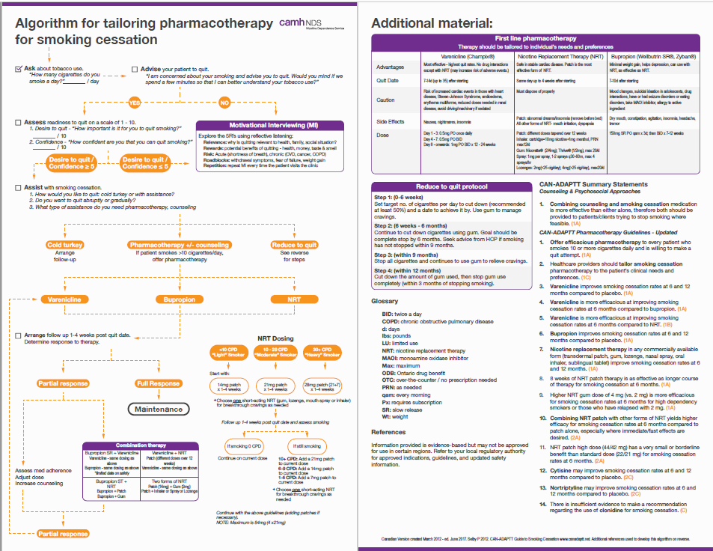

## Supplement 5: Guide to Using Nicotine Replacement Therapy (NRT) Products: STOP Program

**Nicotine Patch (21mg/14mg/7mg):**

* Apply to clean, dry, and non-hairy area of the upper body
* Can secure with medical tape, sock, or an armband
* Wear for 24 hours
* Side effects:
* Localized irritation
  + Remove the entire residual adhesive when removing the patch.
  + Move the patch around to minimize irritation.
  + Use steroid spray before applying the patch if necessary. Can use an over the counter hydrocortisone cream after patch is removed, if necessary.
* Sleep disturbance and vivid dreams (due to presence of nicotine in body overnight)
  + If combination therapy, take the patch off at night. In the morning, put the patch on and use a short acting NRT (gum, lozenge, or inhaler) for the first 30 minutes to control the withdrawal symptoms until the patch kicks in.

OR

* + If no combination therapy, take the patch off at night and set 2 alarm clocks 30 minutes apart. When the first one rings, put the patch on and go back to sleep. By the time the second alarm rings 30 minutes later, the patch would be effective.

**Nicotine Gum (2mg):**

* Works by buccal absorption
* Use the Chew, Chew, Park strategy:
  + Park for 30 seconds adjacent to gums
  + Repeat and move to different gum location (to minimize localized irritation)
  + Effective for 20-30 minutes
* Do not consume acidic drinks/foods, such as alcohol and coffee (wait 15 minutes to use gum)
  + Alters absorption and reduces effectiveness of the gum

**Nicotine Lozenge (2mg):**

* Works by buccal absorption
* Rest the lozenge adjacent to gums, move occasionally (to minimize localized irritation)
  + Effective for 20-30 minutes
* Do not consume acidic drinks/foods, such as alcohol and coffee (wait 15 minutes to use gum)
  + Alters absorption and reduces effectiveness of the gum

**Nicotine Inhaler (10mg, 4mg of nicotine delivered):**

* Do not inhale deeply (takes practice), works by buccal absorption
* How to open/fill/close:
  + Line up etch marks to open and close
  + Insert Cartridge and puncture seal
* Nicotine will be depleted from cartridge in 24 hours even if not used
* Cartridge lasts for 20 minutes of continuous usage

**Nicotine Mouth Spray (150mg, 1mg/spray):**

* Works by buccal absorption
* How to use:
  + Using your thumb, slide down the black button until it can be pushed slightly inward
  + While pushing in, slide upward to unlock the top of the dispenser and release button
  + Must be primed before the first use or if not used for more than 2 days
  + Point the nozzle as close to your mouth as possible, spray into the mouth while avoiding lips
  + Close mouth and do not swallow for a few seconds after spraying
  + Do not inhale while spraying
  + Close the spray after each use
* Use one spray first, a second one if craving does not disappear after a few minutes
* Typically, use 1-2 sprays every half hour. Maximum dose is two sprays at a time.
* May use up to 4 spray per hour, but do not exceed 64 sprays in a 24 hour period
* Do not eat/drink 15 minutes before and after using the nicotine mouth spray

**Links to TEACH Nicotine Replacement Therapy (NRT) Instructional Videos:**

* Nicotine Patch: <https://www.youtube.com/watch?v=uCbH1-qi7eA>
* Nicotine Gum: <https://www.youtube.com/watch?v=MAFuka7li68>
* Nicotine Lozenge: <https://www.youtube.com/watch?v=Tol4jhlNgxk>
* Nicotine Inhaler: <https://www.youtube.com/watch?v=UIyInRGafqs>
* Nicotine Mouth Spray: <https://www.youtube.com/watch?v=_DJSoXQNlfI>

**Tobacco/nicotine cessation/reduction and caffeine consumption:**

* Please note: nicotine makes the body to break down caffeine faster. So, when someone quits or reduces their use of tobacco/nicotine product(s), their body does not break down caffeine as much. Therefore, caffeine consumption should be reduced to avoid potential for caffeine toxicity. Symptoms of caffeine toxicity include anxiety and fidgeting, which are similar to nicotine withdrawal symptoms. Therefore, caffeine toxicity symptoms can be mistaken for nicotine withdrawal and may seem as if the NRT is not working. Please ensure that this information is discussed with the patient and appropriate suggestions with respect to their caffeine intake are communicated.